**Authors:** M.T. Costa, E. Ezcurra, O. Aburto-Oropeza, M. Maltz, J. Botthoff, and E. Aronson

**Title:** Baja California Sur mangrove old, carbon-rich peat deposits inhabited by distinctive microbial community

**Abstract:** Mangrove forests, pantropical coastal wetland ecosystems, provide important ecosystem services including fisheries nursery habitat provision, coastline protection, nutrient cycling, and other local benefits. Of global import is their ability to store carbon in organic peat belowground for hundreds to thousands of years, with more carbon per unit area than any other forest type. Mangrove carbon storage relies in part on the high primary productivity of these systems, but essential to the large and long-lived nature of this storage is the slow microbial decomposition of buried mangrove peat. In this study, we explore the relationship between carbon content and microbial community composition with sediment age and plot the slow course of buried mangrove detritus over time. At four mangrove sites with deep (< 1 m) deposits of peat in the area of La Paz, B.C.S., Mexico, we cored the sediments until rejection with a Russian peat corer, and from these cores obtained 5 cm samples at 20 cm intervals. In these samples we measured total carbon, organic carbon, nitrogen, and 14C age. We observed high percentage carbon by mass (14 ± 6%) and high C:N ratios (29 ± 7) in peat samples. Radiocarbon dates allowed us to reconstruct the accumulation and slow decomposition of organic matter over the last 5,000 years. Limitations on microbial decomposition by microbes, likely help explain this slow decomposition. [Summary of microbial results.] These results shed light on the microbial environment in which these peat deposits are preserved for long periods of time. Future work should examine the roles of distinct microbial taxa in the slow turnover of mangrove carbon. Mangrove forests, long considered detritus-based ecosystems, can only be understood when these belowground carbon cycling processes are captured. Furthermore, data on patterns of belowground carbon in these threatened systems can motivate their conservation, given the value of their ecosystem service of carbon storage, estimated to be worth on the order of 1 billion US$ in the Gulf of California’s mangroves alone.

**Introduction:**

Mangrove forests have been recognized for decades as productive ecosystems that support detritus-based food webs (Odum and Heald 1975). Situated on tropical and subtropical coasts around on the world (Duke 1992), these coastal wetlands also contribute to the productivity of adjacent nearshore ecosystems such as coral reefs through the outwelling of excess production (Alongi 1990). This ecological function of mangroves is made possible by their high rates of primary productivity (Bouillon et al. 2008), exceeding the capacity of grazers to consume locally, and of physical exchange with neighboring environments due to tides. As sources of food and shelter, mangroves have been shown repeatedly also to function as nursery habitats for a wide range of marine and other animals (Nagelkerken et al. 2008). These functions in many cases translate into valuable ecosystem services (Costanza et al. 1997), and in recent decades the subfield of documenting and economically valuing the services mangroves provide for humans has arisen, driven by the alarming 2% global loss of mangrove area annually (Valiela et al. 2001). Mangroves produce timber and other plant products, filter terrestrial run-off, and stabilize coastlines from erosion (Ewel et al. 1998), even mitigating the impact of severe events such as tsunami (Kathiresan and Rajendran 2005). Their nursery habitat function exports fish and invertebrates consumed by people, producing as much as 37,500 US$/hectare each year for coastal fisheries (Aburto-Oropeza et al. 2008). Thus, both in terms of the export of detrital plant matter and indeed of entire organisms, mangrove research has documented the ways in which these ecosystems are sources of production and productivity to the larger environment.

More recently, however, an opposite aspect of mangrove productivity has gained attention in the literature. In addition to mangroves producing and exporting organic carbon, they also act as carbon sinks (Twilley et al. 1992). Though leaf litter and propagules are consumed by detritivores or exported by the tides, woody material including roots can remain unconsumed for long periods of time (Middleton and McKee 2001). Some of this production is buried in vertically accumulating peat deposits, where anoxia and low nutrient availability help preserve organic matter for millennia (McKee et al. 2007). As a result, mangroves and other coastal wetlands globally possess exceptionally high rates of carbon sequestration (Chmura et al. 2003), and soil carbon stocks in these systems surpass those in other types of forests (Donato et al. 2011). The recognition in the last decade of the disproportionately high contribution of mangroves, as well as salt marshes and seagrass beds, to global carbon storage has added a new prong to the study of their ecosystem services, the quantification of the “blue carbon” contained in these ecosystems (Nelleman et al. 2009). Using carbon stock estimates to drive economic investment in the preservation of mangroves has gained attention as a potential tool to mitigate anthropogenic carbon dioxide pollution (Thomas 2014). Though researchers have raced to quantify mangrove carbon stocks around the world (Donato et al. 2011; Adame et al. 2013; Alongi et al. 2016), ecological understanding of the processes that control belowground mangrove carbon stocks is still in its infancy.

Generations of research on estuarine carbon cycling has explored the role of micro-organisms in these ecosystems and their functioning. Early work focused on the role that microbes play in breaking down mangrove primary production or moving it up the food chain to be consumed by animals. Fell et al. (1975) cultured phycomycetes from mangrove leaf litter and tested their impact on its degradation, enriching the material in nitrogen relative to carbon and thus facilitating its use by invertebrate consumers. In a temperate salt marsh/seagrass system, microbial abundance varied significantly with depth, and to a lesser extent with the physical characteristics of the sediment (Ferguson and Murdoch 1975). In the North River mangrove system in Florida, Odum and Heald (1975) discussed the role that microbial partial consumption and attachment to leaf litter particles is essential for their role in the forest’s detritus-based food web. Sediment bacterial densities and productivity rates were shown to possess high spatial and seasonal variability in mangroves of northeastern Australia, where it was estimated that a large part of ecosystem production passes through the bacterial community (Alongi 1988). Bacterial densities also vary between forest types, with greater densities in large deltaic systems than smaller fringe or riverine forests, with productivity rates correlated with availability of DON and DOC (Alongi and Sasekumar 1992). Though sediment microbes and mangrove trees interact biogeochemically, bacterial densities and growth rates vary with edaphic conditions, rather than the species of nearby trees (Alongi et al. 1993). More recent research has shifted attention toward the functional role of microbes in mangrove ecosystems. Balanced methane production by microbes and oxidation in the sediment (Giani et al. 1996), as well as microbial solubilization of mineral phosphate (Vazquez et al. 2000), have both been measured in a coastal lagoon in Baja California Sur, Mexico, with implications for the carbon balance and productivity of mangroves. Finally, researchers have begun the study of microbial diversity in mangrove sediments using genetic sequencing methods (Andreote et al. 2012).

In this study, we study variation in sediment carbon stocks and microbial community composition with depth, and thus age of accumulated sediment. We hypothesized that sediment from deeper, older peat samples will contain lower concentrations of organic carbon and enrichment in δ13C due to microbial consumption over time. We also hypothesize that peat age will be correlated with a shift in the microbial community toward taxa that can consume this refractory remaining carbon and away from the community composition near the sediment surface with greater affinity to marine and terrestrial soil communities.

**Methods:**

Field sites

* Our sites, on islands and the mainland around Bahia de la Paz in Baja California Sur, represent different mangrove environments in this arid, subtropical region near the northern limit of mangroves in the eastern Pacific. With less than 200 mm/year of precipitation, this region is very arid, setting it apart from most areas where mangrove ecosystems are studied and offering an opportunity to see whether patterns observed in the wet tropics extend to this more extreme environment.
* The eastern coast of B.C.S. is also set apart by high elevations extending right up the coast, as can be seen in this elevation map. This true relief map from near our southernmost site facing northward shows that mangrove bays in the area are hemmed in by steep hillsides.
* In work that colleagues and I published last year, we found that the mangroves along these steep coasts feature deeper and older peat deposits… than those at the edge of the broad coastal plain on Baja California Sur’s western coast…. For this study, we chose to study three distinct mangrove sites on the steep Gulf coast of B.C.S. that contain some of this deep peat, delving more into variation in the sediments with depth.

Field Methods

We sampled mangrove sediments using a Russian peat corer (Aquatic Research Instruments), taking vertical, semi-cylindrical sections of sediment 5 cm in diameter and up to 50 cm in length. By adding extension rods, we then returned to the same hole to obtain successively deeper 50-cm sections of sediment. We repeated this process to rejection, when the core tip hit a hard substratum of rock or gravel. Each core section was photographed and subsampled every 20 cm with depth and just above any apparent change in horizon, using a knife and a measuring tape to obtain samples of a uniform 5 cm in vertical extent. Samples for carbon analysis were taken adjacent in the core to samples taken for microbial analysis.

Carbon Analysis

We placed each sample in a drying oven at 60 °C until dry (at least 24 hours). In cases where field circumstances prevented quick access to a drying oven, we kept the samples on ice until they could be dried. We weighed the dried samples and then homogenized them using an automatic grinder and mortar and pestle until they passed through a 500-μm sieve. From each sample, 6-9 mg were precisely weighed into a tin envelope and analyzed by CG-MS (Carlo Erba NA 1500 elemental analyzer), yielding percent carbon by mass and δ13C. Inorganic carbon must be excluded from estimates of blue carbon, so the samples were HCl-fumigated following the method of Ramnarine et al. (2013) to remove CaCO3 before analysis, so that the only carbon remaining was organic. Percent carbon multiplied by the measured bulk density of the sample gives the mass of carbon per unit volume, which, integrated over the depth interval of each sediment horizon and summed for each horizon throughout the entire sediment depth, gives the total belowground carbon per unit area, in tons of C per hectare (Mg/ha).

Molecular Methods

Data analysis

* Zimmerman et al. (2014)
* Caporaso et al. (2012)
* Ramette (2013)

**Results:**

C and C13 results

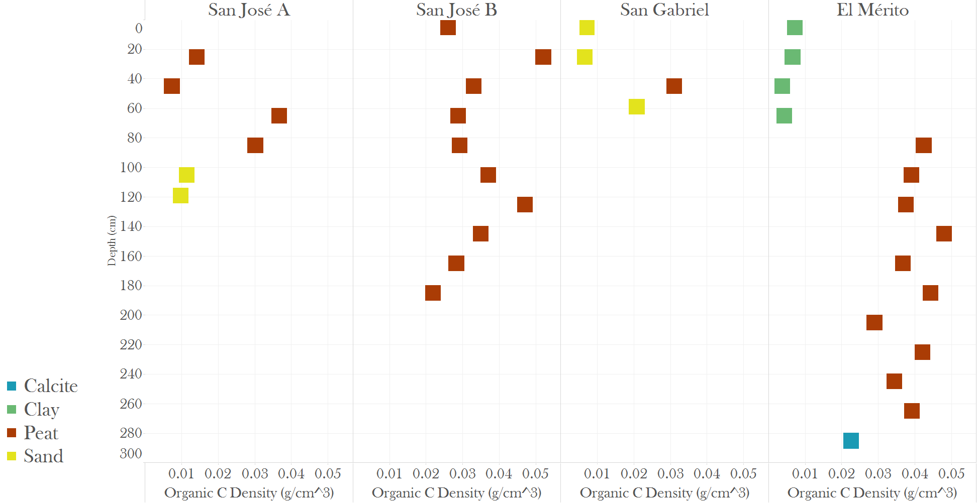

Figure: Organic Carbon

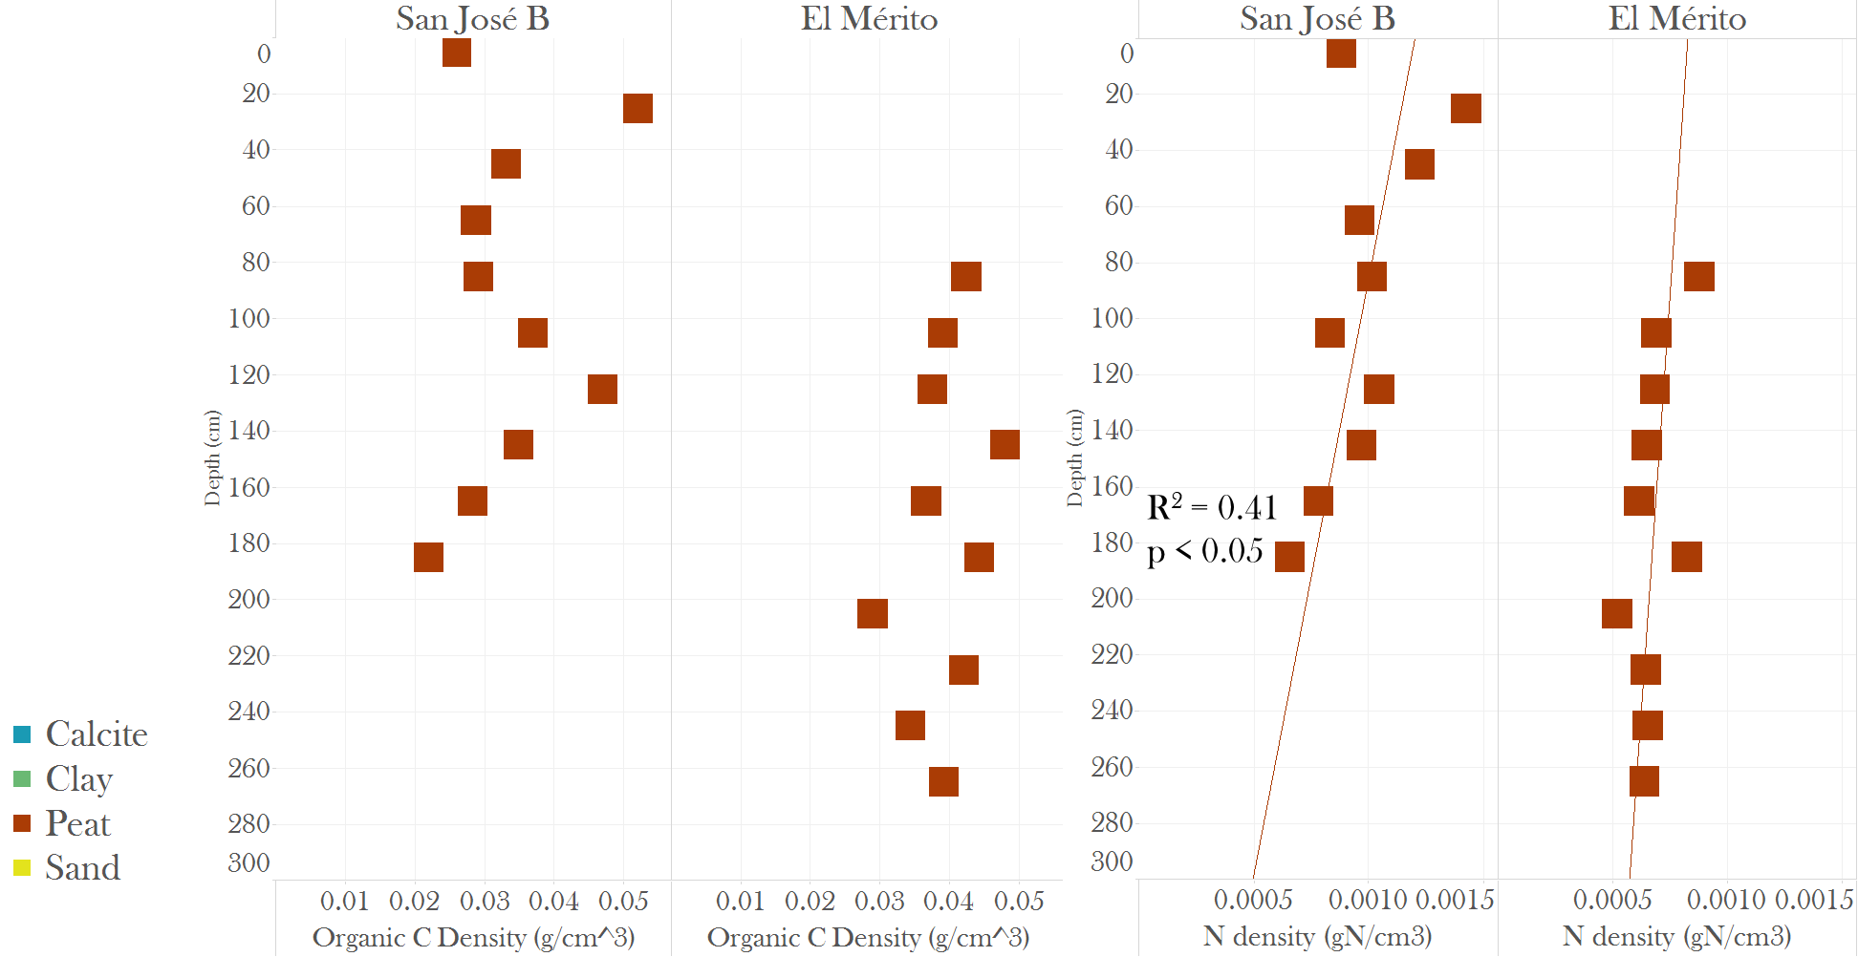

C and N depth trends in peat cores

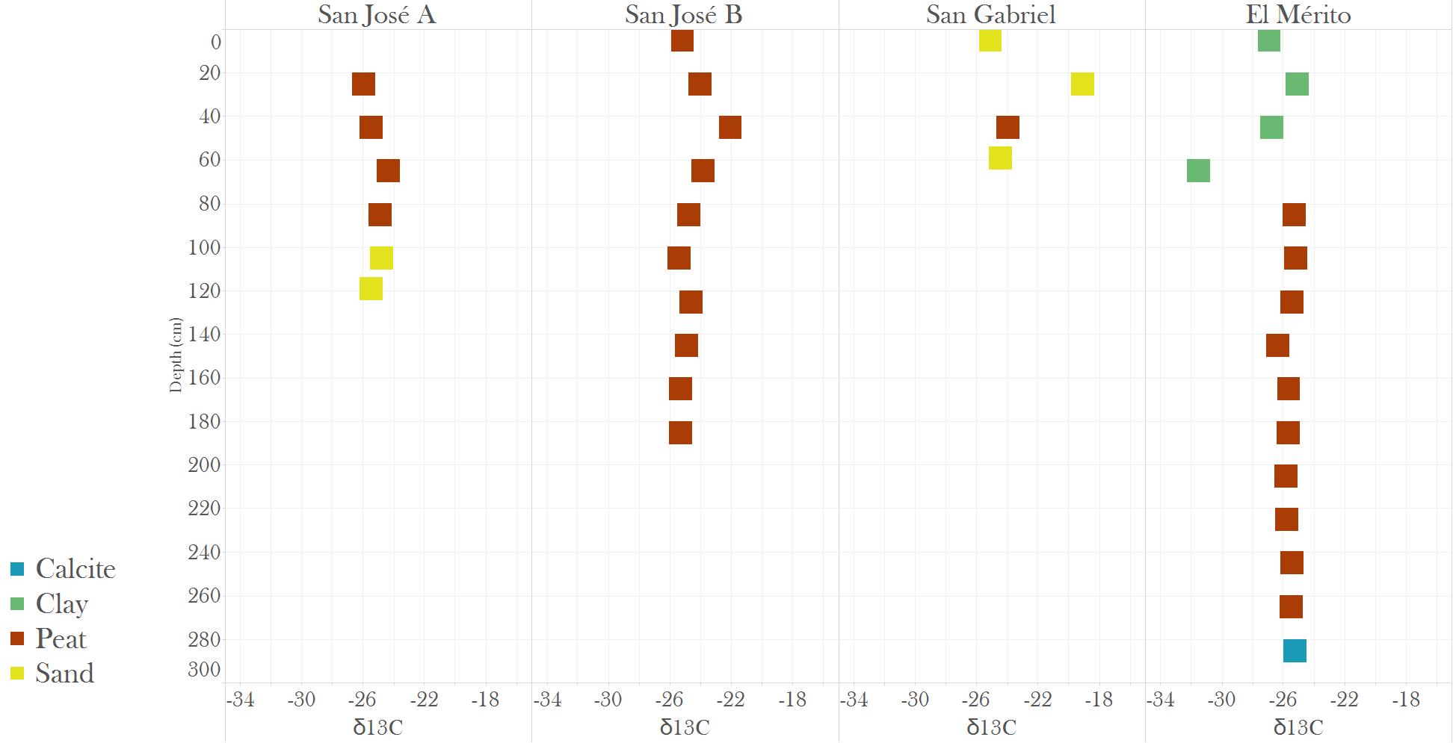

δ13C with depth

C14 age and C accumulation rates

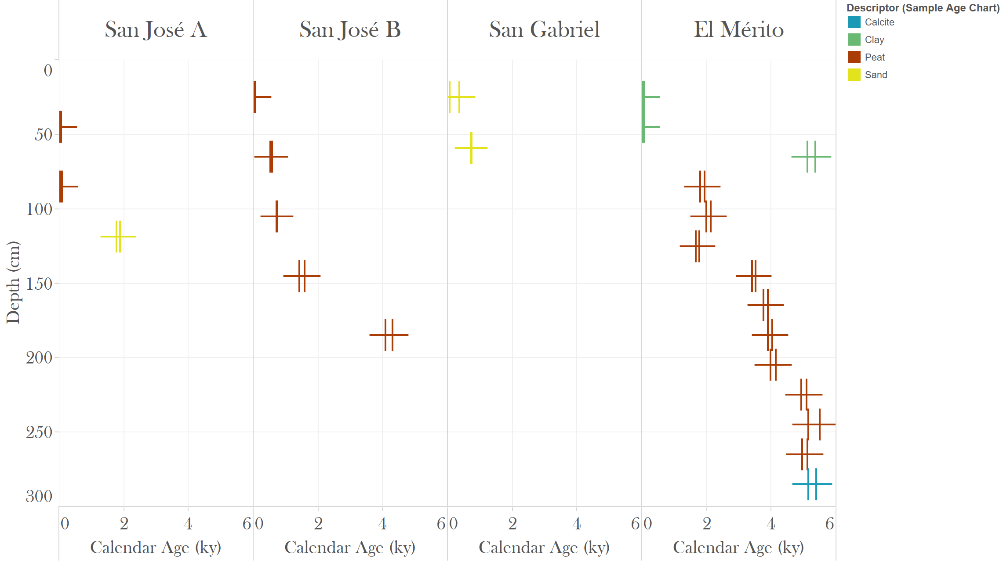

Δ14C age with depth

Microbial Diversity

Physical Correlates with Microbial Community

C and Microbial Community

Age and Microbial Community

**Discussion:**

C Accumulation and Slow Decomposition

Microbial Community Results

Limitations of this Observational Approach

Implications for C Cycling

* Distributional pattern data is available for mangroves; more process-related studies are needed to get at ecosystem energetics. (Alongi and Sasekumar 1992)
* Auta et al. (2018): sediment microbes facilitate plastic breakdown in mangrove sediments

Ecosystem Services and Conservation and Microbial Ecology

* Holguin et al. (2001): role of mangrove microbes for a range of ecosystem services

Opportunities for Future Research

* Role of fungi?

**References (incomplete):**

Alongi, D. M. 1988. Bacterial productivity and microbial biomass in tropical mangrove sediments. Microbial Ecology 15: 59–79.

Alongi, D. M. 1990. Effect of mangrove detrital outwelling on nutrient regeneration and oxygen fluxes in coastal sediments of the central Great Barrier Reef lagoon. Estuarine, Coastal and Shelf Science 31: 581–598.

Alongi, D. M., P. Christoffersen, and F. Tirendi. 1993. The influence of forest type on microbial-nutrient relationships in tropical mangrove sediments. Journal of Experimental Marine Biology and Ecology 171: 201–223.

Alongi, D. M., and A. Sasekumar. 1992. Benthic Communities. Pages 137–171 *in* A. I. Robertson and D. M. Alongi, eds. Coastal and Estuarine Studies. American Geophysical Union, Washington, D.C., U.S.A.

Fell, F. W., R. C. Cefalu, I. M. Master, and A. S. Tallman. 1975. Microbial activities in the mangrove (*Rhizophora mangle*) leaf detrital system. Proceedings of the International Symposium on Biology and Management of Mangroves II: 661–679.

Ferguson, F. L., and M. B. Murdoch. 1975. Microbial ATP and organic carbon in sediments of the Newport River Estuary, North Carolina. Pages 229–250 *in* L. E. Cronin, ed. 1975. Estuarine Research, Volume I: Chemistry, Biology, and the Estuarine System. Academic Press, Inc., New York, NY, U.S.A.

Odum, W. E., and E. J. Heald. 1975. The detritus-based food web of an estuarine mangrove community. Pages 265–286 *in* L. E. Cronin, ed. 1975. Estuarine Research, Volume I: Chemistry, Biology, and the Estuarine System. Academic Press, Inc., New York, NY, U.S.A.